LCD Interfacing to Arduino:
Introduction:
LCDs are commonly used display devices that you would find in most appliances / electronic devices. Your music players, Pay phones, Etc.
Here's an interesting Write up to get you understanding the working of the LCD
http://joshuagalloway.com/lcd.html

Requirment:
- LCD
- Arduino Board
- Breadboard

Hardware configuration:
The IC pin mapping of LCD as shown in given below.

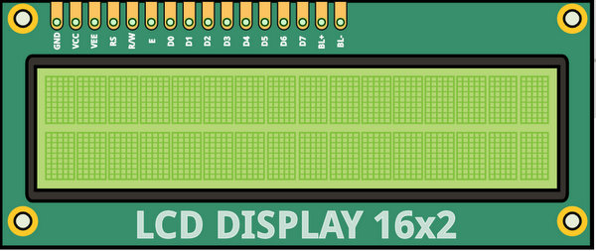
The below steps requried to Interfaceing LCD to Arduino.

Step1: First Connect A Wire between the GND pin of the Arduino and the '-'ve terminal. Then Connect Another Wire from the 5V pin of the Arduino to the '+'ve terminal.

Step2: Place the LCD on the Breadboard (the 16th pin of the LCD is in the LEFT Corner of the Image)

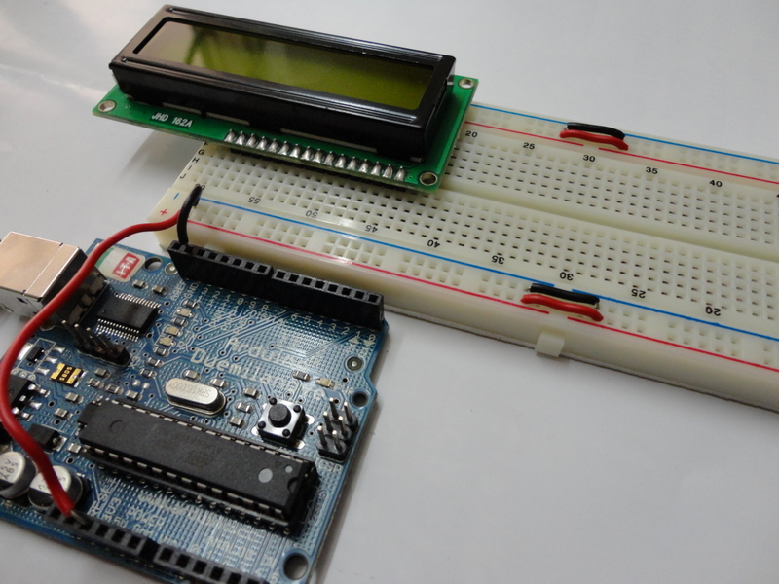
Step3:Place the Trimpot Next to the LCD as shown (a bit away from the LCD pins)

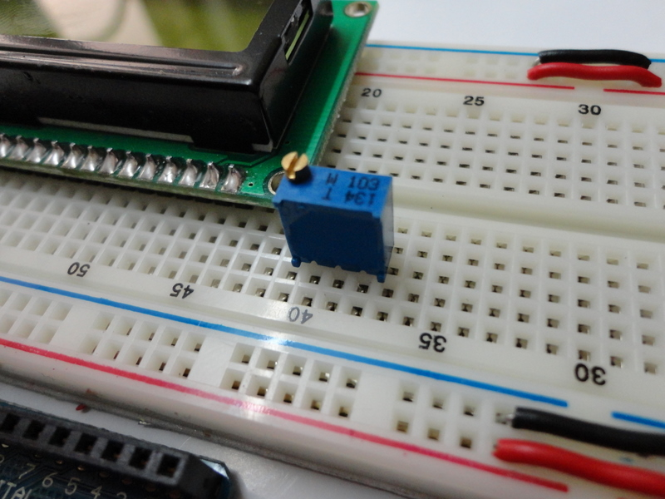

Step`4:Connect the Supply & Ground Lines for the Trimpot

Step5:The First and Last pins of the LCD are GND pins. First Connect a Wire from the 1st pin of the LCD to the '-'ve terminal

Step6:Connect a wire from the 16th pin of the LCD to the '-'ve terminal

Step7: The 2nd & 15th Pins of the LCD are Supply Pins, Connect Wires from these to the '+'ve Terminal.

Step8: The 5th of the LCD is the RW pin. This pin is used to toggle between Read / Write Mode of the LCD. Writing a HIGH signal to this pin corresponds to Read Mode and Writing a LOW signal corresponds to Write Mode. Since we will be using only the Write mode, we can wire this pin to GND / '-'ve terminal [This is equivalent of writing a LOW signal to the pin

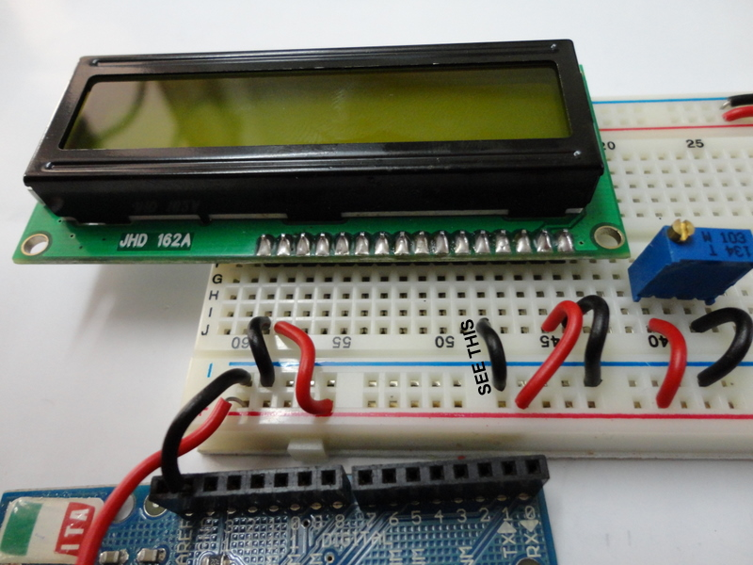

Step9:Connect a Wire from the middle pin of the trimpot to the 3rd pin of the LCD. The 3rd pin of the LCD is the contrast pin and the contrast of the display can be varied by varying the trimpot

Step10: Connect a Wire between the RS pin of the LCD (4th pin) and digital pin 2 of the Arudino. The RS pin helps select between the 2 registers of an LCD - Data & Command - for communication.

Step11: Connect a wire between the Enable pin (the 6th pin) of the LCD and digital pin 4 of the Arduino.

Step12:Connect a Wire between D4 of the LCD (11th pin) and digital pin 8 of the Arduino.

Step13: Connect a Wire between D5 of the LCD (12th pin) and digital pin 9 of the Arduino.

Step14: Connect a Wire between D6 of the LCD (13th pin) and digital pin 10 of the Arduino.

Step15: Connect a Wire between D7of the LCD (14th pin) and digital pin 11 of the Arduino.

The Finished Setup as shown in given below image.
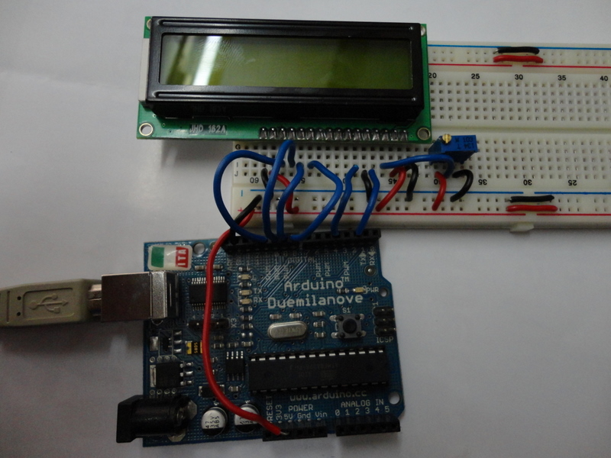

The simple Hellow woard program.

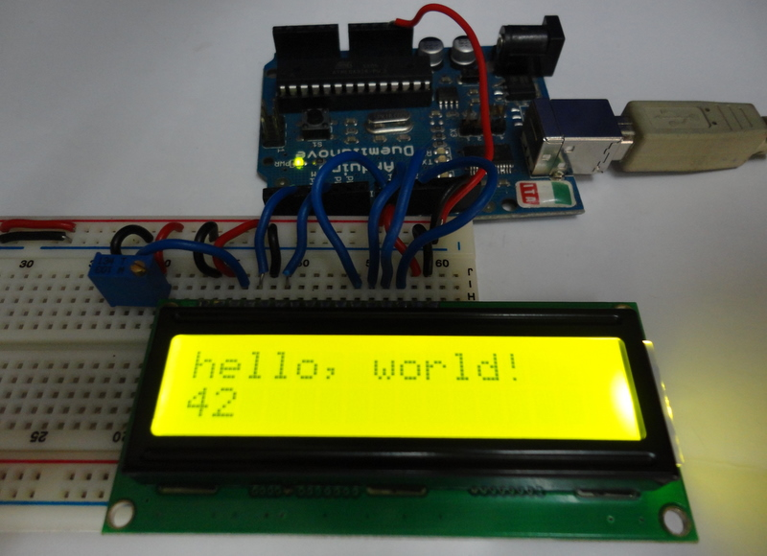
Programing:(source code):

Programming to control the LCD (Hello woard):
the following Simple LCD program [Simple_LCD.ino]
/*
LiquidCrystal Library- Hello World
Demonstrates the use a 16x2LCD display.The LiquidCrystal
library works with all LCD displays that are compatible with the Hitachi HD4478 driver. There are many of them out there,andyou canusually tell them by the 16-pin interface.

*/

// include the library code:
#include <LiquidCrystal.h>

//initialize the library with the numbers of the interface pins
LiquidCrystal lcd(2,4,8,9,10,11);

void setup() {
// set up the LCD's number of columns and rows:
lcd.begin(16, 2);
// Print a message to the LCD.
lcd.print("hello, world!");
}

void loop() {
// set the cursor to column 0, line 1
// (note: line 1 is the second row, since counting begins with 0):
lcd.setCursor(0, 1);
// print the number of seconds since reset:
lcd.print(millis()/1000);
}

Installation:
The source code copy to the skeches of arduino and compile (there is verify option) as shown given below.
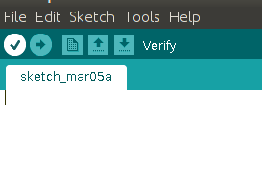

And then uploding the source code.(there is uploding option) to the Arduino board.(software) as shown given below.
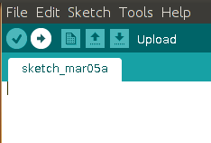

Troubleshooting:
FAQ:
Maintainers:
Duryodhan Aldar (durva.ges@gmail.com)

References: http://quickstartkitforarduino.blogspot.in/

